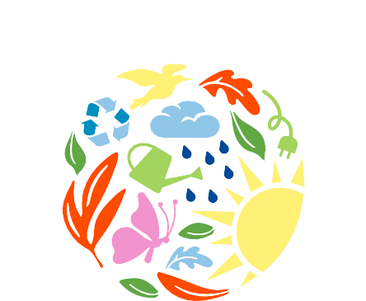

MAKE AN



Just like many bottle caps can become a mosaic, each small action we take in community adds up to major impact!
Choose one action below and make a commitment to complete it within one month.

 PAUSE PLASTIC: RED
- Choose one new food item with less packaging at the grocery store.
- Pick up five pieces of trash on your street.
- Avoid single-use plastics for 24 hours.
- Bring tupperware from home the next time you eat at a restaurant.

 LEVEL UP YOUR KNOWLEDGE: YELLOW/ORANGE/BROWN
- Read a book about an environmental topic that matters to you.
- Invite a friend to watch a nature documentary together.
- Refresh your memory on what’s recyclable in your area: houstontx.gov/solidwaste/recycling
- Learn to patch a hole in your clothes rather than buying a new garment.

 EAT GREEN: GREEN
- Choose one day to eat completely plant-based.
- Buy a food item from a local farmers market.
- Grow an edible plant at home (try tomatoes, basil, or green onions).

 USE YOUR VOICE: BLUE
- Write to your favorite brand and ask how they are working towards sustainability.
- Send an email to your representatives at www.democracy.io
- Share a nature fun fact with a friend! Visit www.hereinhouston.org/local-wildlife for ideas.
- Remind a friend or family member to vote.

 CONSERVE ENERGY: BLACK/GRAY
- Hang dry your clothes the next time it’s sunny.
- Challenge your family to a “No-Power Hour:” one hour without using any electricity!
- Choose one day to walk, bike, or take the bus to school, work, or the library.
- Spend ten minutes researching a heat pump or a solar energy provider for your home.

 ENGAGE YOUR COMMUNITY: WHITE
- Volunteer with a local group to plant trees, pick up trash, or work in a community garden.
- Donate five dollars to a local community organization.
- Attend an event on the Houston Environmental Calendar: cechouston.org/cec-calendar







- Share your Eco-mmitment on social media and challenge your friends to make one too!



